How Do I Create Assignments?
Click Create
Choose Assignment
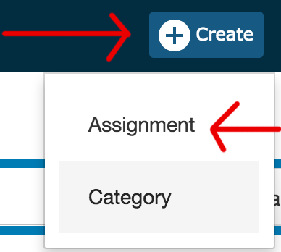
Complete 1 - 6
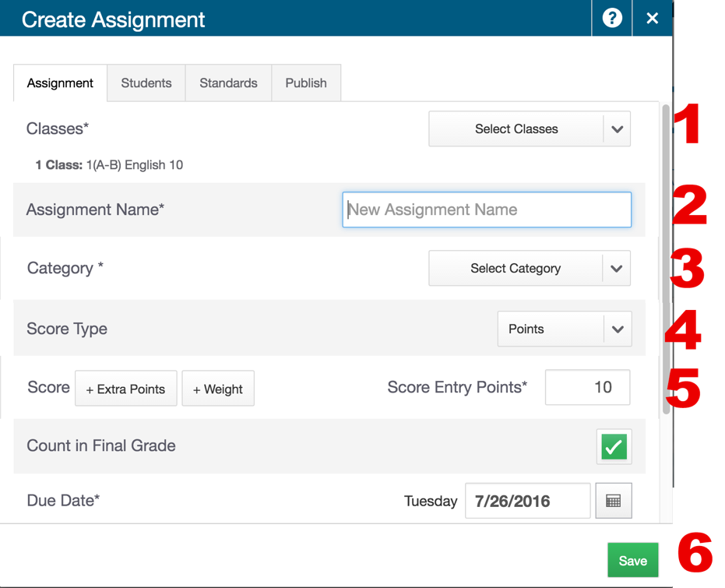
1 - Choose class(s) - click up arrow when done
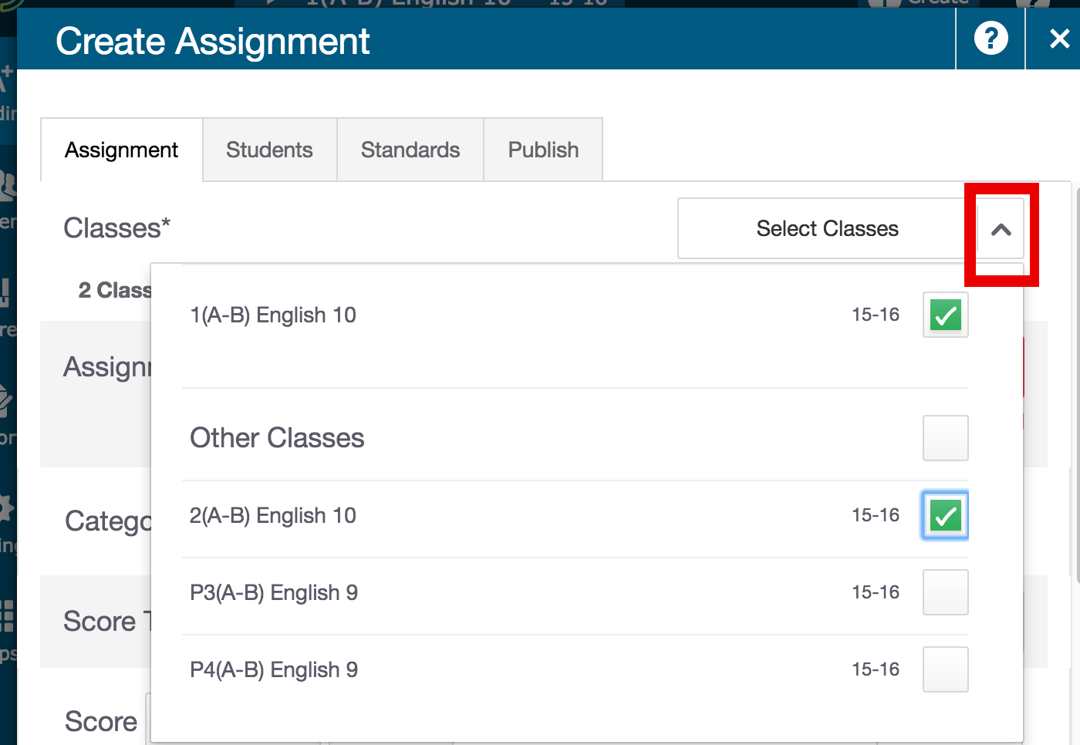
Name assigment
Choose category
Choose score type
Type in points possible
Include in final grade
Select a due date (defaults to today)
Click save.
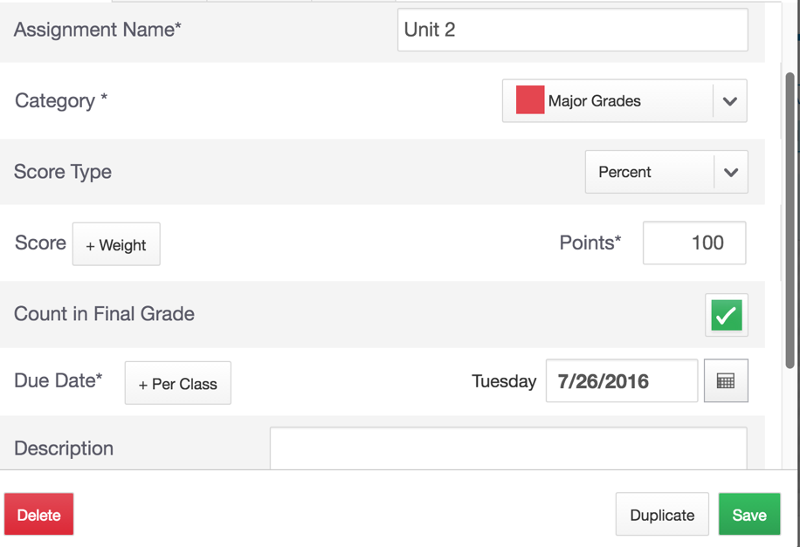
Green bar indicates SAVED
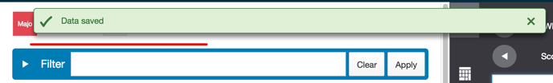
Click on assigment
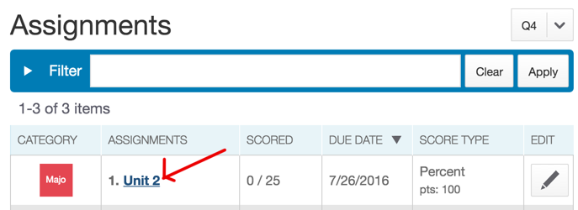
Enter scores
