GPA Data

The GPA DAT parameters are separated by spaces, not semicolons. The parameters values are separated from the parameter by an equal sign and enclosed in quotes. It is not necessary to use every parameter, as omission of a parameter will trigger a default value, but it is often more helpful to clearly define all parameters in a GPA DAT string to avoid any ambiguity.
Note: If you plan to enter parameters (e.g. term, grade,...etc.) in the *gpa DAT code, verify the corresponding Query Options are blank under the GPA Calculation Methods at the District level. For more information, please refer to article 7182: How it Works: GPA Calculation Query Options.

Format:
^(*gpa method="[gpa method]" type="[gpa type]" term="[term1],[term2],[etc]" grade="[grade]" credittype="[credit type]" year="[year1],[year2],[etc]" scale="[grade scale]")

Parameters
Method:
^(*gpa method="simple")
This code will pull the GPA based on the calculation method (GPA methods are found at District setup > GPA Settings > GPA Calculation Methods). For example, if you list "simple" as the method, it will calculate the GPA based on that calculation method. If omitted, the "weighted" calculation method is used. To learn more about GPA Calculation methods, refer to Knowledgebase Article 7182 .
Type:
^(*gpa type="type")
This code will pull the GPA based on the calculation type. There are 3 possible options here: cumulative, current and projected. Cumulative is based on historical (stored) grades, current is based on current (grade book) grades, and Projected is based on both historical and current grades. If omitted, the "cumulative" calculation type is used. If current grades are used, the term, grade, or year parameters are ignored. A projected type attempts to predict a student"s GPA, based on stored or current final grades, as defined in the calculation method used. [StoredGrades] or [PGFinalGrades].
Term:
^(*gpa term="S1")
^(*gpa term="Q2,Q3,Q4")
This code will pull the GPA based on the listed term(s). For example, if you list "S1" as the term, it will only search grades that were stored with an "S1" store code, and ignore all others. Values must exactly match a store code (for historical grades) or final grade name (for current grades). Any values that do not match are ignored. Multiple term values are separated by commas. If the term parameter is omitted, all existing store codes or final grades are used in the calculation. Note that if the term parameter is used without also using the year parameter, only grades from the current year will be used. [PGFinalGrades]FinalGradeName or [StoredGrades]StoreCode.
Grade:
^(*gpa grade="10")
This code pulls the GPA based on the grade level. For example, if you list "10" as the grade, it will search only grades that were stored during a student's 10th grade(contains a grade_value of 10 in the historical grade record). The same works with using multiple grade levels. If omitted, it will search the historical grade range that is set for the school. [StoredGrades]Grade_Level.
Credit Type:
^(*gpa credittype="SCI")
^(*gpa credittype="SCI,MAT,ENG")
This code will pull the GPA based on the course credit types. For example, if you list "SCI" as the type, it will only search grades that were stored from a course that had a credit type of "SCI". The same works with using multiple credit types. If omitted, it will search all available credit types. Credittype values must be an exact match with the credit type value as it appears in the stored grade record. [StoredGrades]Credit_Type.
Year:
^(*gpa year="2004")
^(*gpa year="2003,2004")
This code will pull the GPA based on the year. For example, if you list "2004" as the year, it will only search grades that were stored for courses during any term for that year. The same works with using multiple years. If omitted, it will search all available years. [StoredGrades]TermID.
Scale:
^(*gpa scale="Default")
This code will pull the GPA based on the grade scale. For example, if you list "Default" as the grade scale, it will only search grades that were stored for courses using that grade scale. The same works with using multiple years. If any grade is not present in the specified grade scale (for instance if a grade of "X" is found in a record, while the specified scale only lists the traditional A-F scale), that grade will not be included in the calculation. If the name of the grade scale itself is unrecognized, a PowerSchool default scale named "Default" is used. If the parameter is omitted, the calculation will use the actual grade point values as entered in the historical record. [StoredGrades]GradeScale_Name.
Multiple Options Example:
^(*gpa method="simple" term="S1,S2" year="2003")
This is a code using multiple options with multiple search entries. It will pull the GPA using the "simple" calculation method, and it will be based on only courses that were stored with the "S1" and "S2" store codes, during the 2003-2004 school year. Since the other options were omitted, the defaults listed above are used during the search.
Example Stored Grades Record:
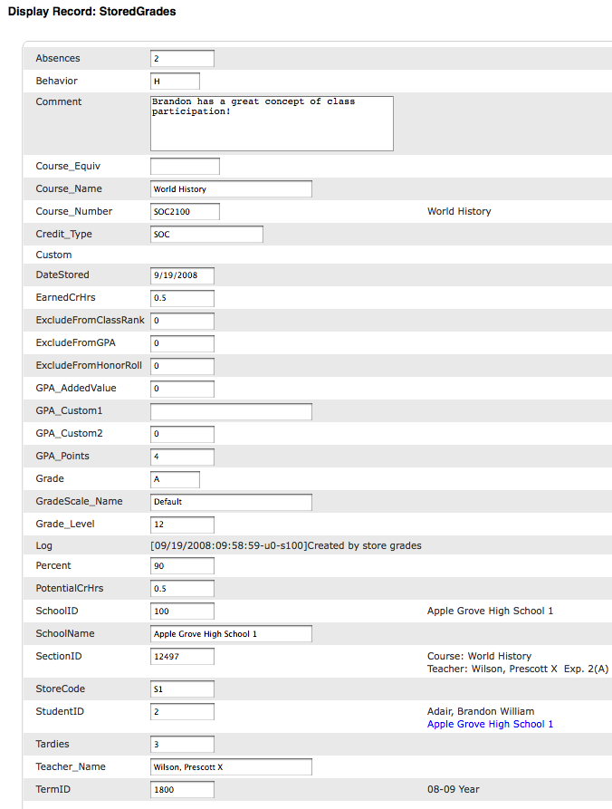
Example PGFinal Grades Record:
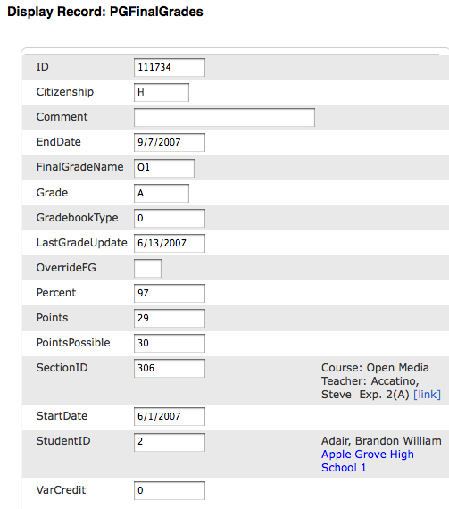

Comments

