Additional notes for PowerTeacher:
Seating Charts:
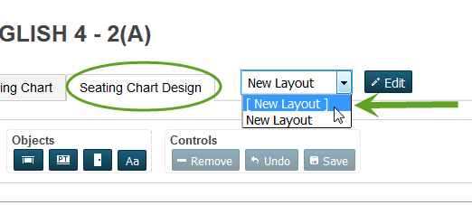
Creating a ‘New Layout’ –
- Select a period to create a seating chart for by selectin the icon that is a Chair with a Grid
- Select the ‘Seating Chart Design’ tab
- Select [New Layout] from the pull down menu
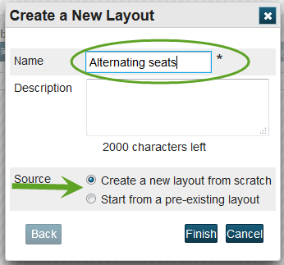
- Name your layout – if this is the first new layout you are creating, select to ‘Create a new layout from scratch’ – if you have a pre-existing layout, you may select to use the pre-existing layout.
- Select either Finish or Next depending on your Source selection
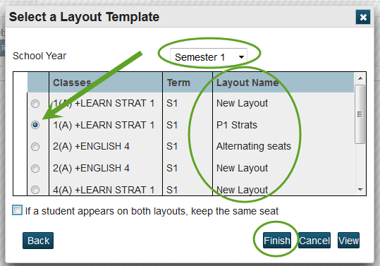
- IF you have selected to use a pre-existing layout, you will need to select the Year and term the layout you want to copy is located.

Selecting this second option pre populates your room & desk layout.

Combo Classes: Once you have created a seating chart layout – if you have a Combo Class or multiple classes that meet during the same period.
- Select your seating chart design
- Select Edit
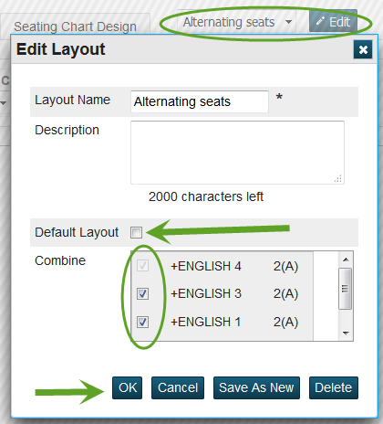
- Select ALL classes you would like included on the seating chart
- Select to save the seating chart, save the seating chart under a new name (must change Layout name at top)
- You may also make the seating chart the Default Layout

Class Description or Assignment Description:
The new PowerTeacher Pro does not have Content Groups to store web links, but you can still add a link to your class description or to an assignment description. You will do this using html formatting. You will need a beginning and ending tags <a href= “ “ > & </a> to your web address.
Example:
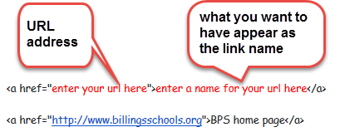
This is how it will appear in your Class Description:
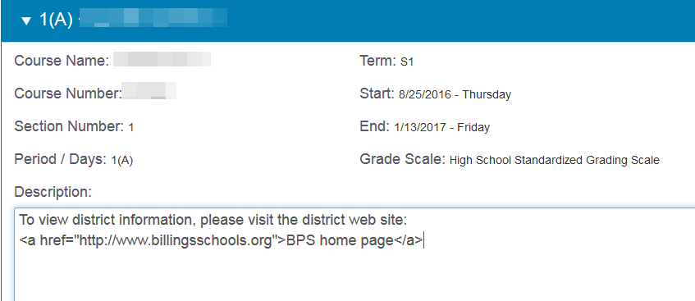

When parents or students go to your class description on Quick Lookup, they will see:
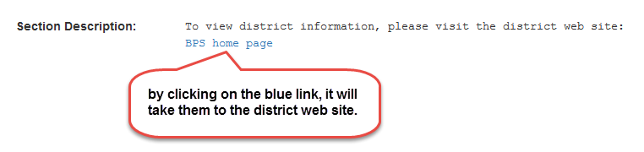

** to check and make sure your have formatting the link properly – add it to a class description and then go to Quick Lookup for a student in that class. Select the current grade link area to see the Section Description.
